**Jadav Payeng: The Man Who Planted an Entire Forest by Himself**

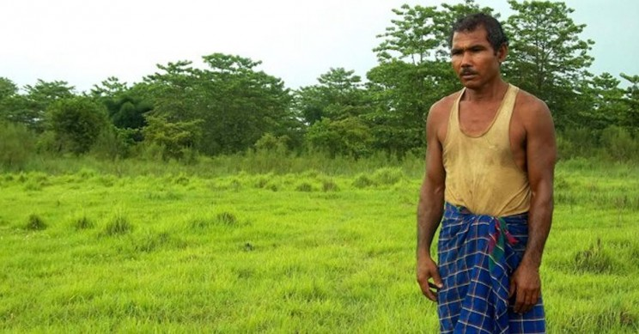Jadav Payeng, known as the Forest Man of India, spent 30 years of his life planting trees to save his island, creating a forest and restoring wildlife in it.

Jadav Payeng is better known as the Forest Man of India. He earned this name by spending 30 years of his life planting trees, creating a real man-made forest of 550 hectares. Thanks to this reforestation, wildlife has returned to the area. Incredibly, he did it all by himself. This is his story.

**Molai Kathoni forest: A one-man-made forest**

The Mulai Reserve is a forest on the Majuli Island in the [Brahmaputra River](https://www.britannica.com/place/Brahmaputra-River" \t "_blank) near Kokilamukh in the Jorhat district in Assam, India. It has a total area of about 1,000 hectares and is under continuous threat due to the [extensive soil erosion](http://www.omafra.gov.on.ca/english/engineer/facts/12-053.htm" \t "_blank) on its banks.

Majuli has shrunk over the past 70 years by more than half. There are concerns that it could be submerged within the next 20 years. To fight this, in 1980, the Assam Forestry Division of Golaghat district began a plan to reforest 200 hectares of the forest in one of the sandbars of the Brahmaputra river. See more